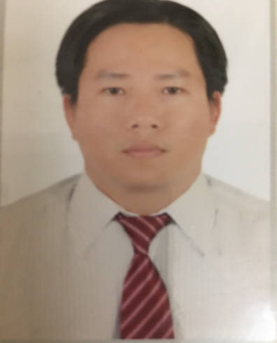 | Nguyen Van Dung  Address: 141/1 Lương Văn Nho street, Tân Phong ward, Bien Hoa City, Dong Nai Province.  Phone Number: 0983113011  Email Address: nguyendunglhu@yahoo.com  Saintpaul69@gmail.com
EDUCATION
Lachong University, Vietnam
Department: Economics
Degree: BA
Date: December 2001

Paramount of Technology University
Department: Economics
Degree: Master Business Administration
Date: November2007
Thesis: Human resource development solutions Dongnai province, Vietnam

Bulacan State University, Philippines
Department: Business Administration
Degree: Doctor of Philosophy in Business Administration.
Date: 2016
Dissertation: Pencils application model in order to develop brand of Lachong university

PATENTS AND PUBLICATIONS
Patents:
Patent number:
Title:

Publications
- Nguyen Van Dung, Phan Thanh Tam “Determinants of Vietnam’ S Economic Growth from
2010 to 2019”Test Engineering and Management, vol 83, pp. 26205-26213, 2020.
- Nguyen Van Dung, Phan Thanh Tam“The researching of the brand development: the case of Lachong university in Dongnai province”, vol 76, Kaav International journal of Economics.
- Nguyen Van Dung, "Factors Affecting the Quality Management of Enterprises in Dong Nai Province " Journal of Business Management and Economics, Vol. 29, No.3, pp.12990-12997, 2017.
- Nguyen Van Dung and et al., “Recommendations Enhancing the Brand Advertising Effectiveness of Lac Hong University” Journal of Business Management and Economics, Vol. 29, No.3, pp.12990-12997, 2016.

- Nguyen Van Dung and et al., “Factors influencing online marketing development of small
and medium enterprises in dong nai province” British Journal of Marketing Studies, Vol 27, pp. 1-11, 2018.
- Nguyen Van Dung and et al., “Reliability statistics for factors affecting brand advertising
effectiveness: a case of lac hong university” British Journal of Education, Vol 31, pp. 1-10, 2019.
- Nguyen Van Dung and et al., “The reliability statistics of the essential factors affecting a
successful start-up in Vietnam” British Journal of Education, Vol 6, pp.26-37, 2018.
HONORS, AWARDS, AND PRIZES
Awards

